
Castles project

LI: The pupils will devise a code of conduct that they will adhere to when using Minecraft
Preparation work in class.
Minecraft class rules
In groups brainstorm rules that should apply during Minecraft lessons. Select five rules that you all agree ought to be put in place.
Write the agreed rules in the boxes below.
Finalised Rules
Don’t disturb others
Don’t get out of seat
No sabotaging others work
No cheating with command codes
No shouting across the room.

When undertaking this project, you and your team will be judged and assessed on the following criteria:

- Teamwork and communication skills
- Most historically accurate recreation of a Norman Castle
- Accurate Labelling of the defensive features of a Norman Castle

Materials for building a Castle
LI: Using numeracy to work out resources needed for building the Castle
You are now going to decide which materials you will need to build your Castle.
Materials should be from the 12th Century and freely available in Ireland/Britain at the time of the Normans.
One Minecraft block should equal 0.5 metres this will help you assess how many blocks you might require. Try to estimate how tall the wall and turrets need to be.
1 Block = 0.5 Metres
Example
The White Tower in London, built by William the Conqueror in 1078, is 36.6 by 32.8 metres and has walls 4.6 metres thick.

Materials/Items | Quantity
Stone
Wood
Brick
Iron bars
Doors
Water
Fences
Hay
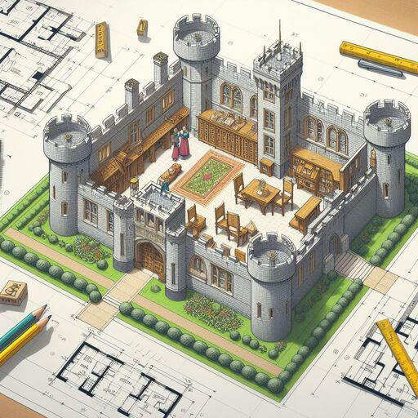

Features of a Castle
LI: The pupils will learn the features of a Norman Castle
You must include and label the following in your Castle:
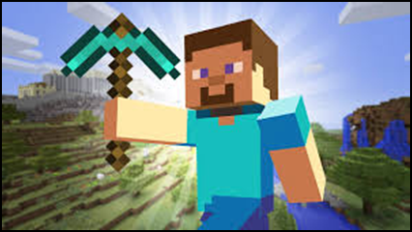
- A Curtain Wall
- A Tower House
- A gate (portcullis)
- Defensive features
- Turrets
- Arrow Loops
- High walls

You must work together in teams of 4/5 to build your Castle to the highest standard possible. The building must look as if it is from 12th Century Ireland/Britain.
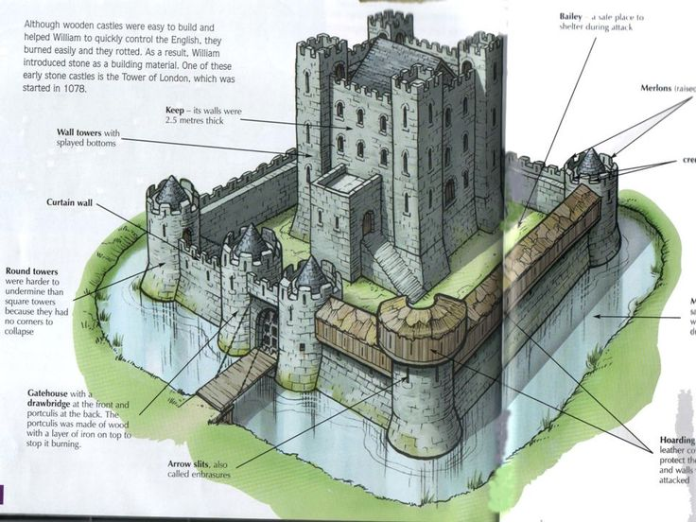
Examples of how a Castle should look!
Castle 2
Castle 1
Floor plan

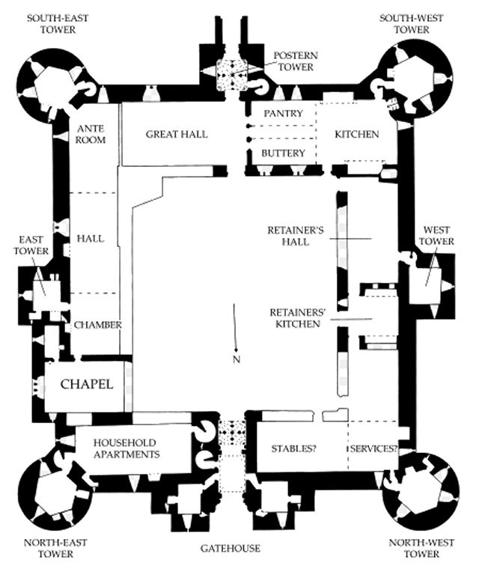

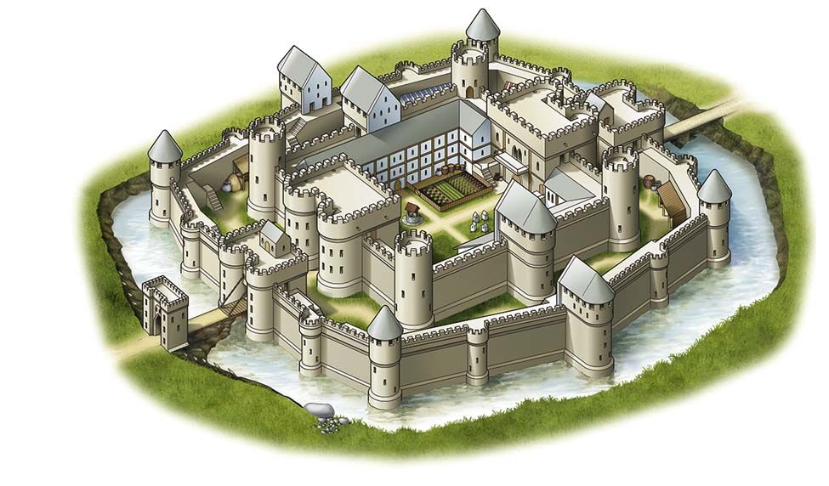

GET BUILDING!!!
Assessment

Area assessed | Mark out of | Score
Teamwork | 10
Communication | 10
leadership | 10
Numeracy  (working out quantity of building resources - worksheet) | 20
Literacy  (Labelling of features) | 20
Historical accuracy | 30
Total | 100

